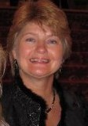
VESTRY CANDIDATES - 2019
Liz Fitzgerald: Liz Fitzgerald seeks to serve on St. Michael’s Vestry to continue her outreach to underserved communities. In her previous parish life in Roanoke VA and Raleigh, NC, Liz, along with her husband, Bruce Roach, tutored refugees in literacy programs and helped families there adapt to life in a new country. Education and literacy proficiency are key areas of interest to her. This year, while still a newcomer to St. Michael’s, she discovered the parish’s Immigration Work Group. This group identified novel solutions for the successful sanctuary of the Panzu family, and Liz found a resonance for her time and talents. Some of her time she spent introducing the children to the joys of library membership, providing school transportation on various days, and having fun around time with Bela and her children. As the family transitioned to Philadelphia, Liz located literacy programs for the family and food pantry solutions in their new neighborhood. Liz has championed the rights of immigrants, refugees and asylum seekers and actively participates in social action through the group, Indivisible Nob Hill. She wants to bring about changes in laws that affect these populations and reduce the climate of fear in this country. Liz is also a certified Yoga instructor and has been providing Yoga to the All Angels Day School.

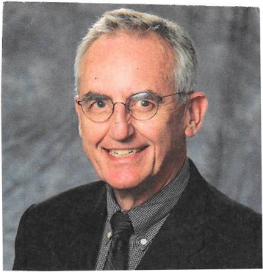
MICHAEL BOURDREZ
I was born in the Netherlands and came to New York with my parents at the age of eight. I graduated from Friends Seminary, a private Quaker school in New York City, and earned a Bachelor of Arts and Master of Architecture from Columbia University. I married my high school classmate and have two sons and two grandchildren. Diana, my wife of 51 years died in 2017. I practiced architecture until 1991 when I joined the non-profit National Council of Architectural Registration Boards in Washington, DC. Diana was a photo editor and worked for various publishing companies in New York, New Jersey and Washington, DC. After retirement in 2008 we moved to New Mexico and settled in Corrales. I continued to consult for the National Architectural Accrediting Board until 2017. In Washington we were members of St. Alban’s Episcopal Church where I served on the vestry there for three years. In early 2009 we found our spiritual home at St. Michael’s. I have served the church as lector, usher and servant at the altar, activities that did not impact my responsibilities as primary caretaker for my wife in recent years. I now have much more time to devote to the church and am eager to serve on the vestry at St. Michael’s.
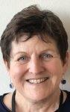
Robin Swift
I found St. Michael's in June at the invitation of friends. From the very first time, I was struck by its easy warmth, intentional liturgy and stellar preaching. I joined Loose at 9, and it's the highlight of my week to rehearse and sing with them. Baptized at 8, I married into the Episcopal Mafia in 1987, am the widow of an Episcopal priest and mother of a PK surgical resident. I have lived in NM since 2013, in Albuquerque for 2 years, and work at UNM's Project ECHO. I served on the vestry and search committee of St. Joseph's, Durham, NC (when Bp. Hunn was there).
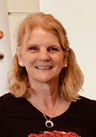
Jennifer Kepesh
I am a cradle Episcopalian (with a brief Pentecostal rebellion in adolescence, and a couple of years in a welcoming Methodist church when no Episcopal churches were close by). Because of frequent moves, I’ve been a member of many churches, and I’ve been deeply involved in many church ministries throughout my life: acolyte (and directing acolytes), lay reader, Eucharistic Visiting, chalice bearer, many music ministries; Vacation Bible School, J2A sponsor, children’s education, adult education, fundraising, Worship Committee, Canterbury Ministry, Search Committee, Stewardship, Prayer Guild, and more. When I moved to Albuquerque in 2009 (to begin a second career as a Montessori teacher), I chose to become a member of St. Michael’s because of its diverse community, its activism, the variety of worship experiences available, the intellectual engagement, and the sense of a cohesive community even with four Sunday services. As a vestry member, I would seek to support a vibrant community with worship as our center, fellowship to surround and support us, and outreach ministries that allow us to be Christ’s hands and heart in our community and the world.

Cori Hetzel
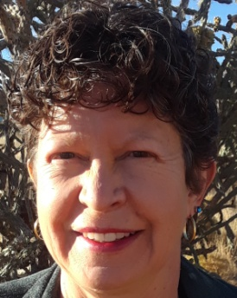
After being drawn to St. Michael’s for years, I started attending 1 1/2 years ago and was very warmly received into our community in June. I sing in the 9:00 choir and find deep joy and friendship there while supporting our congregation in worship through music. A Universal Sufi for 23 years, I serve as Secretary on the Federation of The Sufi Message Council, an international organization that embraces our unity in God through diversity on the Sufi path. Since late 2017, I have been on the planning committee of the yearly gathering that was held in 2018 near Paris, France and now for 2019 in Charlottesville, VA. I enjoy learning about everyone’s unique gifts and talents, then we weave these together in ways that serve God, each other and our communities. I love singing at our 9 am service, the Arts in Spirituality programs, teaching an art process called Mandalas; Luminous Symbols for Healing, the new Soul Break and helping in the Liturgical Arts. I am also the Event Facilitator here for singing groups that rent our beautiful Sanctuary for performance. I have a lifelong love for Elders and now find that I am one myself here with so many other Elders! Professionally, I am a nurse who works with Elders by advocating for and facilitating what is most important to them and their loved ones. I co-facilitate the monthly Heartwork Circle; Conscious Elderhood and End-of-Life Ministry. I attend the Care for the Caregivers Ministry monthly meetings now to help provide support. If chosen as a Vestry member, I will bring an open and willing Heart to work with our Vestry to help discern and do God’s Will for and through our Life Together.

Candidates for Delegates

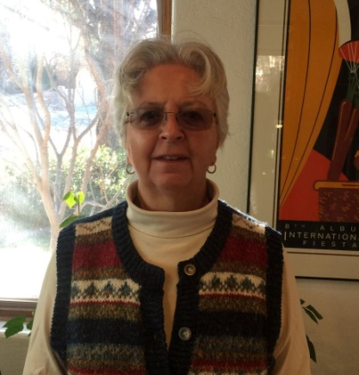
Barbara Koenig
I have been a member of St. Michael and All Angels since late 1991. During those thirty-odd years I have learned how important our parish’s messages and ministries are to the wider community. If I am elected as one of your delegates to the Northwest Deanery of the Diocese of the Rio Grande, I would try to carry our message of love, acceptance, active community-based ministries and financial transparency to the Deanery and to the Diocese. I would attend the Deanery meetings and the Diocesan Convention emphasizing these principles as we make the business decisions that shape the work of the Diocese. During my years at SMAA I have been a warden, a Vestry (junior) warden, a Treasurer and have served on many committees. I have attended diocesan conventions and deanery meetings over the years and believe I have the experience to act as an informed representative of SMAA in our wider church.

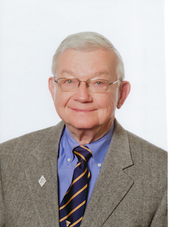
Dale Lange
As a member of the St. Michael’s family, I am completing a three year term on the Vestry (2015-2018). During that time, I have served on the Special Task Force, which helped bring the budget deficit under control, examined, codified, and modernized church policies, and was instrumental in eliminating the church mortgage. Within the Taskforce duties, I worked on the Endowment Policy and Financial Management Policies. During this same period, I was liaison between the Vestry and the Finance Committee, and co-chair of the Navajo Partnership Ministry (2018 only). I also sang with the 11:15 choir for a year (2016-17) until my wife needed me as her caretaker. I also attended several Diocese meetings, one that specifically involved finance and certainly those meetings that involved the choice of the new Bishop. My professional background is that of professor, University of Minnesota, where I was also Associate Dean for academic affairs in the College of Education and Human Development. In that role, I was responsible for the college curriculum, professional licensure programs, advice and consent to the dean on promotion and tenure, as well as the collegiate budget. I believe that my background and the experience that I have gained at St. Michael’s provide me with the necessary orientation to serve as a delegate to the Diocese from this church.

