November 18, 2018
We wish you and your loved ones a very
Happy Thanksgiving!
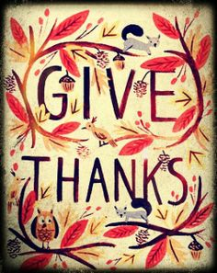

PARISH THOUGHTS ON IMMIGRATION: Thanks for your feedback and conversation on the Immigration ministry last week. Your concerns and support provide helpful guidance. Find more information and results soon at http://www.all-angels.com/immigration-sanctuary.html.

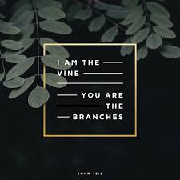
2019 STEWARDSHIP: As we come into this time of fall and harvest and into our annual stewardship campaign, we reflect on Jesus’ words, “I am the vine, you are the branches. Those who abide in me and I in them bear much fruit, because apart from me you can do nothing.” (John 15:5). We consider how each of us, being the branches that radiate out from Jesus the one true vine, extend our reach into the world. Our “reach” means many things. It means offering compassion to those in need and understanding to those with whom we disagree. It means witnessing to the value of truth, integrity, and generosity. It means perseverance and determination where there seems to be good reason for apathy and despair. It means living in a spirit of self-sacrifice for the sake of the common good. Our reach means living in the spiritually committed in our “life together.” We ask you to think and pray on how our gifts – both as individuals and a community – are woven together in our life in Jesus. Then, in hope and gratitude, complete your pledge card to support the mission and ministries of St. Michael’s in 2019. You can also complete a pledge card online at: www.all-angels.com/giving.
IN GATHERING SUNDAY IS TODAY!
If you want offering envelopes for the coming year,
they are available in the Parish Hall and in the Parish Office.
ST. MICHAEL’S BREAD BAKERS GUILD seeks new members! We provide the recipe and can provide training. A weekly supply includes three small, one medium, and one large whole-wheat loaf; usually, we are responsible for a month (including extra services) but can split this up depending on volunteers' preferences. If you are interested, please email Jennifer Kepesh at jen_kepesh@yahoo.com (or leave a message with Kathryn at the office).

BIBLE STUDY CONTINUES: Bible study continues on Sundays at 10:15 in the library with the Gospel of John. For more information, contact Rachel Slater (rjsltr@unm.edu).

THE WELL: Save the date for our next trial Saturday afternoon service at 4:30 pm on December 15!

NOMINATIONS FOR VESTRY AND DIOCESAN DELEGATES: The Vestry Nominating Committee is seeking interested candidates to serve on the Vestry for three-year terms or as delegates to Deanery meetings and the annual convention for two-year terms. If you are interested in one of these positions, you may contact one of the members of the Nominating Committee: Patrick Reilly at patdanareilly@msn.com, Dale Lange at dalelange@aol.com, Kathleen Moore at blueport39@outlook.com or David Odegard at davidcodegard@gmail.com. The committee members will explain the nominating process and time commitments involved in serving a position. Elections for new Vestry members and delegates will be at SMAA's annual meeting held on January 27, 2019.

CASA SAN MIGUEL FOOD PANTRY: So, you haven't finished putting away your Halloween or Día de los Muertos decorations and you're just starting to think about how big the turkey should be when you go shopping for Thanksgiving dinner foodstuffs and you're already getting creeped out with all the Christmas decorations and music in the stores. Well, let us add a little to your angst. The food pantry will start collecting Christmas gifts for children this coming Sunday, November 18. This is early, but Christmas Day falls on a Tuesday, this year, so we need to start a wee bit early so we can distribute toys on all four Tuesdays before Christmas.

PARISH OFFICE VOLUNTEERS NEEDED: The parish office needs Volunteer Angels the week of December 17th. Are you able to help? You can work half-day shifts. We will need help getting ready for Christmas as our parish administrator will be out of the office. Many thanks!

YOGA ON BREAK: The 7am Wednesday class in on a break through the end of the year. We will re-evaluate continuing in January. Are you interested in teaching a Yoga class here? Talk to Kathryn in the office.
ADVENT BEGINS ON SUNDAY, DECEMBER 2!
10:15 am Annual Advent Event: Wreath Making, Cider and Biscochitos
PARISH ADVENT RETREAT, DECEMBER 8 - 9
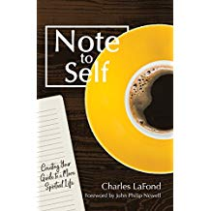
Join us at the Black Range Lodge in Kingston, New Mexico, for “Bringing Holy Order to Busy Lives: How to Write a Rule of Life,” led by Episcopal priest Charles LaFond. Charles is an experienced retreat leader and prolific author, most recently of Note to Self: Creating Your Guide to a More Spiritual Life. The retreat begins at the Black Range Lodge at 1:00 pm on Saturday and ends at noon on Sunday. In between, we will enjoy workshop sessions at the Lodge, fellowship at Pastor Joe Britton’s home in Hillsboro, and worship at the historic Christ Church. Saturday dinner, Sunday breakfast, and lodging are included in the registration fees of $90/person for single occupancy or $75/person for double occupancy. You can register at the Retreat Table in the Courtyard on Sundays or by contacting Mandy Taylor-Montoya (345-8147, ext 121 or MandyTM@all-angels.com). Please note registration and fees are due TODAY.

THE NEW MONASTICISM:
Models of Christian Living in Today’s World
A Sunday Forum series through, November 25, 10:15 am
Pastor Joe Britton

GREAT COURSES: Meets on Wednesdays 1:30 – 3:30 pm in the Pavilion, led by the Rev. Alan Conley, member of St. Michael’s and retired priest from West Texas: 830-459-9789 or email rev.alan.conley@gmail.com. Show up whenever you can. We are starting a new series made up of short courses on the arguments of the Founding Fathers about the constitution: “The Great Debate: Advocates and Opponents of the American Constitution.” Presenter is Prof. Thomas Pangle of the Dept. of Government at the Univ. of Texas, author of The Ennobling of Democracy. November 21: No Class – Happy Thanksgiving!
November 28: Disputing Separation of Powers, Parts 1 and 2
December 5: The Supreme Court and Judicial Review; The Bill of Rights

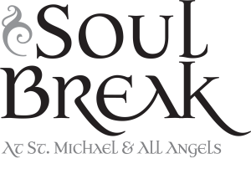
Join us WEDNESDAYS for a short contemplative service of prayer, song, scripture and silence,
every Wednesday from 6 – 6:30 pm,
followed by silent meditation until 7:00 pm.
NO SERVICE THIS WEEK, NOVEMBER 21

WRITING RETREAT at the Norbertines: Waiting in Wonder and Hope: A Meditative Writing Retreat, with Meg Ashcroft, Saturday, December 1, 2018, 9 a.m.-4 p.m.,at Santa Maria de la Vid (Norbertine) Abbey, 5825 Coors Blvd. SW, Abq. While some people are engaged in a buying frenzy this time of year, others want to quietly anticipate a season of Loving Presence. A sense of wonder and welcome can be our companion in this period of active waiting. This retreat offers time and space to simply be, something that is not always easy for us as the demands of the world press us to do and consume more and more. Our attentive stillness can be a refuge, and a way of embracing our desire for peace in ourselves and in our world. The offering for the retreat day is $55.00, which includes lunch. All are welcome to participate-no writing experience is necessary! Please register by Monday, Nov. 26, by calling 505-873-4399, or emailing MAshcroft@norbertinecommunity.org.
KEEPING YOUR CONTACT INFORMATION CURRENT: You might be surprised how many emails bounce and phone numbers are no longer working or mail gets returned to us. In order for us to keep you informed on parish matters we need your updated contact information. Thank you so much - just contact Kathryn in the office to update your information: 505.345.8147 ext 111 or email office@all-angels.com

OFRENDA: Thank you for participating in this year’s ofrenda. Pictures that have not been claimed are in the small conference room of the parish office. You can pick them up during the week during office hours or on Sunday. Not all the pictures have names on the back and some are left over from last year. Please come claim your pictures of your dearly departed.

QUODLIBET will be in concert at St. Michael's on December 1st at 7:00 pm. They we will also be caroling at the Old Town Stroll on December 7 at 7:00pm and in Belen at the Harvey House Museum/Bugg Light Display on December 15th at 6:30 pm.

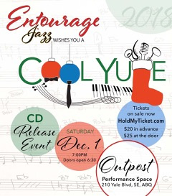

https://holdmyticket.com/event/324140

CALL FOR ENTRIES: Expressions of the Spirit: Images of Belief and Faith. November 16, 2018 - January 6, 2019. Gallery St. Michael offers an opportunity for visual artists to share 2-dimensional works that explore spirituality, belief and faith in a variety of expressions. The exhibit will be shown in the Pavilion of St. Michael and All Angels Episcopal Church. Artists may submit up to 5 pieces. All pieces should be ready to display, including appropriate weight wires and hangars. Canvases may be left unframed if the sides are finished (gallery wrap). Please email the number, names, and sizes of works to gallery@all-angels.com before November 14. For publication purposes, email your jpeg images or photos of your submissions with title and medium by November 16 to the same address. There is a 25% commission for all sales, which supports this St. Michael and All Angels’ ministry. Please bring your work to the Pavilion at St. Michael and All Angels Episcopal Church, 601 Montano Road NW, Albuquerque NM 87107 on Wednesday, November 14, 4:00 - 5:30 pm. Pick up work on Wednesday, January 9, 2019, 4:00 - 5:30 pm. The Artist Reception will be Friday, November 30, 6 - 8 pm.

